**Рисование (Рисование.exe)**

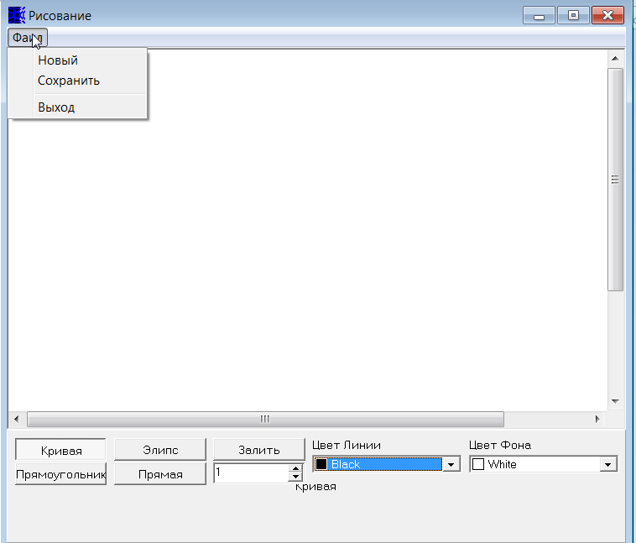

**Приложение для рисования разных фигур. Можно выбрать фигуру, нажав на соответствующую кнопку, толщину линии (с помощью стрелок или ввести вручную) и мышкой протянув нарисовать фигуру нужного размера. Также можно выбрать цвет линии и заливки(фона). При рисовании нескольких фигур, одна накладывается на другую, т.е.по верх первой. Фигуры по рабочей области перетаскивать нельзя. Для заливки необходимо выбрать цвет фона и мышкой нажать на облость закрашивания. Рисунок можно сохранить только с помощью меню.**

**1.** Напишите идеи чек листа, которые вы выполните для проверки работоспособности этой программы. Запишите возникшие у вас вопросы.

|  |  |  |
| --- | --- | --- |
| 1. Create new file | 1. save and open the empty file via the folder where it is saved |  |
| 1. select line thickness 10 using the arrows | 1. exit the programme via the menu |  |
| 1. select line thickness 10 using the keybord |  |  |
| 1. select a square, draw a line thickness of 1 by keyboard, background colour white |  |  |
| 1. select a square, draw a line thickness of 10 by keyboard, background colour white |  |  |
| 1. select ellipse, draw line thickness 1 by keyboard, background colour white |  |  |
| 1. select ellipse, draw line thickness 10 by keyboard, background colour white |  |  |
| 1. select a rectangle, draw a line thickness of 1 by keyboard, background colour white |  |  |
| 1. select a rectangle, draw a line thickness of 10 by keyboard, background colour white |  |  |
| 1. select a straight line, draw a line thickness of 1 by keyboard, background colour white |  |  |
| 1. select a straight line, draw a line thickness of 10 by keyboard, background colour white |  |  |
| 1. select a curve, select a line colour yellow and draw with thickness 1, select the thickness by using the arrows, background colour white |  |  |
| 1. Select ellipse, select line colour red and draw with thickness 1, select the thickness by using the arrows, background colour white. |  |  |
| 1. select a rectangle, to choose a line colour green and draw with a thickness of 1 by keyboard, select the thickness by using the arrows, background colour white |  |  |
| 1. select a straight line, to choose a line colour orange and draw with a thickness of 1, to choose a thickness by using the arrows, background colour white |  |  |
| 1. change the background colour to red and draw a square with a line thickness of 5 by keyboard, the line colour black |  |  |
| 1. select background colour green, draw a white circle with thickness 3, a grey rectangle with thickness 8 by keyboard, a black straight line with thickness 15, a red curve with thickness 10, save file |  |  |
| 1. draw a rectangle in line colour black, fill with yellow, thickness 16 by keyboard, background colour white |  |  |

**Questions to the requirements:**

1. what is the maximum line thickness?
2. what line colours available? what background colours?
3. limits on the number of figures drawn at the same time?
4. what is the size of the working window
5. where is the file saved by default?
6. what type the saved file has?
7. What should the curve look like? Is it based on a template or does the user draw it themselves?

**2.** Напишите основные тест-кейсы, которые Вы выполните для проверки работоспособности этой программы. Запишите возникшие у вас вопросы.

|  |  |  |  |  |  |  |
| --- | --- | --- | --- | --- | --- | --- |
| **ID** | **Priority** | **RQ** | **Title** | **Description** | **Expected result** | **Comments** |
| 1 | smoke |  | Draw rectangle | 1. Create new file with name “rectangle” 2. Select rectangle 3. Select color line red 4. Select thickness of line 5 using arrows 5. Draw by mouse on workspace | 5. Red Rectangle thickness 5 drawn |  |
| 2 | smoke |  | Draw ellipse | 1. Create new file with name “ellipse” 2. Select ellipse 3. Select color line green 4. Select thickness of line 10 using keyboard 5. Draw by mouse on workspace | 5. green ellipse thickness 10 drawn |  |
| 3 | smoke |  | Draw curve | 1. Create new file with name “curve” 2. Select curve 3. Select color line blue 4. Select thickness of line 1 using arrows 5. Draw by mouse on workspace | 5. blue curve thickness 1 drawn |  |
| 4 | smoke |  | Draw straight | 1. Create new file with name “straight” 2. Select straight 3. Select color line black 4. Select thickness of line 2 using arrows 5. Draw by mouse on workspace | 5. black straight line thickness 1 drawn |  |
| 5 | critical |  | changing the background, drawing shapes, saving work | 1. Change background color on black 2. Select rectangle 3. Select color line white 4. Select thickness of line 5 using arrows 5. Draw by mouse on workspace 6. Select ellipse 7. Select color line green 8. Select thickness of line 2 using arrows 9. Draw on rectangle by mouse 10. Select curve 11. Select color line red 12. Select thickness of line 15 using arrows 13. Draw on ellipse by mouse 14. Select straight 15. Select color line blue 16. Select thickness of line 8 using arrows 17. Draw on curve by mouse 18. Save file | 5. a white rectangle with a thickness of 5 on a black background  9. a green ellipse with a thickness 2 on rectangle with a thickness of 5 on a black background  13. a red curve with a thickness 15 on green ellipse with a thickness 2 and rectangle with a thickness of 5 on a black background  17. a blue straight with thickness 8 on red curve with a thickness 15, green ellipse with a thickness 2 and rectangle with a thickness of 5 on a black background  18. save file in the folder with default path | 1. where is the file saved by default? TBD |
|  |  |  |  |  |  |  |
|  |  |  |  |  |  |  |
|  |  |  |  |  |  |  |
|  |  |  |  |  |  |  |
|  |  |  |  |  |  |  |
|  |  |  |  |  |  |  |
|  |  |  |  |  |  |  |
|  |  |  |  |  |  |  |
|  |  |  |  |  |  |  |
|  |  |  |  |  |  |  |
|  |  |  |  |  |  |  |
|  |  |  |  |  |  |  |
|  |  |  |  |  |  |  |
|  |  |  |  |  |  |  |
|  |  |  |  |  |  |  |
|  |  |  |  |  |  |  |
| **3.** Напишите баг-репорты по замеченным «нюансам работы» приложения. Я не предоставляю Вам технического задания на данную программу, поэтому просто укажите все проблемы (ошибки, проблемы в ГУИ и т.п.), которые Вы считаете, заслуживают исправления. Запишите возникшие у вас вопросы. **Пожалуйста, начните с наиболее серьёзных ошибок!**   |  |  |  |  |  |  |  |  |  |  | | --- | --- | --- | --- | --- | --- | --- | --- | --- | --- | | **ID** | **Title** | **Description** | **Steps to reproduce** | **Reproducibility** | **Severity** | **Priority** | **Exp. Result** | **Actual Result** | **Attachment** | | 1 | The name of the selected shape is behind the button"Прямая" and thickness selection | The name of the selected shape is behind the button"Прямая" and thickness selection | 1. open "Рисование.exe" | always | Medium | normal | The name of the selected shape down than button"Прямая" and thickness selection | The name of the selected shape is behind the button"Прямая" and thickness selection | <https://drive.google.com/file/d/1QMq7OXDXrH-HukxkpVumJZH40hDNt6B7/view?usp=sharing> | | 2 | The shape name does not change when the shape is changed | The shape name does not change when the shape is changed | 1. clicking button "Элипс" 2. clicking button "Прямоугольник" 3. clicking button "Прямая" | always | medium | normal | 1. the name of the current figure "Элипс" 2. the name of the current figure "Прямоугольник" 3. the name of the current figure "Прямая" | 1. the name of the current figure "Кривая" 2. the name of the current figure "Кривая" 3. the name of the current figure "Кривая" | <https://drive.google.com/file/d/1_-Aoo9Z3nG-c5fAn5LKKhB-u1Ho_kv5g/view?usp=sharing> | | 3 | Grammatical error in the name of the figure button "Элипс" and top menu "Фаил", it should be "EлЛипс" and "ФаЙл" | Grammatical error in the name of the figure button "Elipse", it should be "Ellipse" | 1. open "Рисование.exe" | always | minor | normal | 1. button name are "ЭлЛипс" and and "ФаЙл" | 1. button name are"Элипс" and "Фаил" | <https://drive.google.com/file/d/1h31wyNLv-AWS0YI0KyiZOohbqJbeqR5n/view?usp=sharing> | | 4 | line colour name in English | line colour name in English , the app itself in Russian | 1. click to change color line on "Black" | always | minor | low | interface language is Russsian | color line language is english | <https://drive.google.com/file/d/17pM69fpHMUCAzbYAN1A3N5Cs8O0dTG5K/view?usp=sharing> | | 5 | the thickness goes to minus when selecting with the arrows and entering with the keypad | the thickness goes to minus when selecting with the arrows and entering with the keypad | 1. enter into line thickness -2 2. change thickness to -5 by arrows | always | critical | high | 1. input is not available 2. input is not available | 1. input available 2. input available |  | | 6 | Change background color issue | no possibility of changing the background | 1. open "Рисование.exe" | always | major | high | 1. there is a field for selecting a background change | 1. there isn't field for selecting a background change |  | | | | | | | |

4. Написать саммари к TRR (задание выполняется опционально)

**Test result report**

**Рисование (Рисование.exe)**

**01.12.2022-15.12.2022**

**Test team:**

|  |  |  |
| --- | --- | --- |
| **Name** | **Position** | **Role in the project** |
| Daria Pavlovskaya | Tester | Functional testing |

**Testing process description:**

Test environment: OC Windows 11 build 20208.

Test level: System testing.

Test types used: Functional, GUI, Localization.

All test scenarios were created based on requirements from doc for Control work (see Control Work Module 1 by email) using black-box techniques.

All tests performed manually

**Summary:**

News: Project starts closes on 15.12.2022

Test Analysis: There are 6 bugs found, it seems as expected , as this build is for training testing.

**Testing timetable:**

|  |  |  |  |
| --- | --- | --- | --- |
| Tester | Date | Description | Duration |
| Daria Pavlovskaya | 5.12.2022 | Creating check-lists for check that the programme is working; creating basic test cases; creating bug report; | 3h |

**Recommendations**:

I would recommend to focus on corrections for basic functionality first and only then proceed with new features development.

**New bugs found:**

|  |  |  |
| --- | --- | --- |
| 1 | Medium | The name of the selected shape is behind the button"Прямая" and thickness selection |
| 2 | medium | The shape name does not change when the shape is changed |
| 3 | minor | Grammatical error in the name of the figure button "Элипс" and top menu "Фаил", it should be "EлЛипс" and "ФаЙл" |
| 4 | minor | line colour name in English |
| 5 | critical | the thickness goes to minus when selecting with the arrows and entering with the keypad |
| 6 | Medium | Change background color issue |

**All bugs statistics:**

|  |  |  |  |  |  |
| --- | --- | --- | --- | --- | --- |
| **Status** | **Quantity** | **Severity** | | | |
| **Critical** | **Major** | **Medium** | **Minor** |
| New | 6 | 1 | 0 | 3 | 1 |